Capstone Project Phase B

**Detection of multiple skin disorders**

**Project Number:**  23-1-R-8

**Supervisor:** (Dr.) Zakharia Frenkel

**Team members:** Oudai Salameh 206978454 Oudai.Salameh@e.braude.ac.il

Or Mizrachi 311161285 [or.miz1993@gmail.com](mailto:or.miz1993@gmail.com)

GitHub link: <https://github.com/Oudai46/Detection-of-multiple-skin-disorders>

Google Drive Links:

Full Project:

<https://drive.google.com/drive/folders/1_T1ghKs5HY9o6fwpIeM1TA7ISPyzrkx7?usp=sharing>

Data: <https://drive.google.com/drive/folders/1_eWjFvoxhGrUwZYNR87bhxpk5bDnojqA?usp=drive_link>

Weights:

<https://drive.google.com/file/d/1Kd44MVYLm4bhN19ApOulZUJZl8o2zwJ6/view?usp=drive_link>

**Table of Contents**

**Contents**

1. Introduction…………………………………………………………………..4-5

1.1 Paper Organization………………………………………….………...5

2. Background and Related Work ……………………………………………..5-9

2.1. Similar programs ……………………………………………...............9

2.1.1 Skin Check: Dermatology App ……………………….............9

2.1.2 Aysa application………….. ………………………................10

2.1.3 AI Dermatologist Skin Scanner ……………….......................11

2.2 The Networks……………….................................................................11

2.2.1 Convolutional neural network…………………………….11-12

2.2.2 Convolution Layer: ……………………………………….12-13

2.2.3 Pooling Layer:……….……………………………………13-14

2.2.4 Soft Attention:……….………………………….……………14

2.2.5 Categorical cross entropy loss: …………………………...14-15

2.3 Previous fellows arcthitecture ..……………………………….………15

2.3.1 ResNet …………………………………………………………15

2.3.2 ResNet50 ………………………………………………………15

2.3.3 DenseNet …………………………………………………...15-16

2.3.4 DenseNet121 ………………………………………..…………16

2.3.5 Inception ResNet v2 – IRv2……………………………………16

2.3.6 Networks we will use in our project………………………...16-17

3. Expected Achievements…………………………………………………….…17

4. Research process………………………………………………………………17

4.1 Desireable functionallity……………………………………………….17

4.2 Our Solution…………………………………………………….…..18-19

4.2.1 Use Case Diagram……………………………………………….19

4.2.2 Class Diagram ……………………………………………….….20

4.2.3 Deployment Diagram ……………………………………….….20

4.2.4 Simple User Flowchart …………………………………………21

4.2.5 Datasets………………………………………………………….21

4.2.6 GUI…………..………………………………………………22-23

5. Verification plan……..……………………………………………………………...24

6. Evaluations.………………………………………………………………………..24-25

7. Conclusions……………………………………………………………………….....26

8. Maintenance Guide…………………………………………………………….....26-27

9. References ………………………………………………...………………………...28

**Abstract.** *Skin disorders are very common, and they affect as many as one in three Americans at any given time. Common skin conditions include acne, contact dermatitis, benign tumors, cancers, atopic dermatitis (also called eczema), and psoriasis. Our research project presents a solution of building a system of mass wisdom, which will allow patients to share and upload pictures of their skin and create a huge database that will improve the ability to diagnose and detect skin diseases. The project is based on a model of convolutional neural networks (Inception ResNet V2 and Densenet-121. The datasets proposed on this article are collected from DermNet and PCDS (primary care dermatology society) website. The model discussed on the paper will allow analysis and detection of skin disorders even on low-quality images taken on mobile devices. The networks will undergo constant training and improve their predictions, in addition, users will have the option to enter personal medical data that significantly improves the prediction level.*

*Keywords: CNN, Inception ResNet V2, Densenet-121, Deep learning, Skin disorders, Soft Attention.*

*.*

# Introduction

Skin is the largest organ in the human body, due to its large scale it has high potential to get infected by various infections and lesions, and it is very vulnerable to bites and rashes. One of the most common type of skin disorders is Acne a common skin condition that affects most people at some point. It causes spots, oily skin and sometimes skin that's hot or painful to touch.

Acne causes pimples mostly on the face, forehead, chest, shoulders and upper back. There are a variety of causes including genetics, fluctuating hormone levels, stress, high humidity and using oily or greasy personal care products.

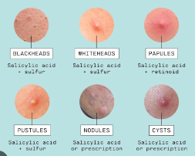

Acne peaks in adolescence and early adulthood, affecting around 85% of people between the ages of 12 and 24. Though it is often thought of as a teenage problem, acne can occur in people of any age, though it grows less common as time goes on. Still, over 25% of women and 12% of men in their 40s report having acne.

So our main goal is to develop a reliable, faster and accurate platform which will help private users to get an early indication of various skin diseases and save the long medical procedure bureaucracy.

The solution is an application using external user data such as: age, background diseases, health habits e.g. Furthermore, the application will use medical datasets of various skin disorders images which will be used in the learning process of the deep learning algorithm explained in our paper.

* 1. **Paper Organization**

On section 2 we will present the theoretical and scientific background which led us forming our model to the article. On this section we will describe researched and other related works of the topic. Section 3 describes the goals we would like to achieve. On section 4 we will describe our product include our solution and the models, datasets and architectures used to implement our idea. This section includes flowchart of the system, UML (Use Cases, Deployment diagram) and Class diagrams. The final section 5 describes the verification plan supposed on this paper and the GUI

# Background and Related Work

We have reviewed couple of researches related to the topic. Most of these projects based on AI algorithms using various deep learning architectures of Convolutional Neural Networks (CNN), others used computer vision methods in order to analyze different disorders. The datasets used on each research are medical datasets which will be explained in details as with the algorithms used on each research

In [1] they have applied transfer learning approach using the pre‐trained mobilenet‐v2 model for skin disease classification. For both binary and multi‐class classification of skin diseases, using image data alone the output of the pre‐trained model was flattened and fed to the classifier. The classifier then uses the concatenation of both the image data and patient information to classify the skin disease.

The dataset used were total of 1137 images along with patient information was collected from Dr. Gerbi medium clinic and 239 images from Boru‐Meda General hospital using a smartphone camera. About 300 of the images were collected from healthy skin and 1376 from abnormal skin affected by acne vulgaris, atopic dermatitis, lichen planus, onychomycosis and tinea capitis.

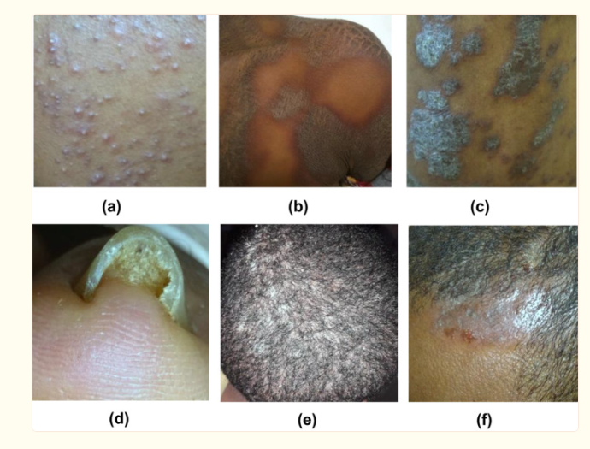

Figure 4: abnormal skin affected by, (a) acne, (b) vulgaris, (c) atopic dermatitis, (d) lichen planus, (e) onychomycosis and (f) tinea capitis.

In [2] the researchers used support vector machine (SVM) to classify melanoma skin cancer. They collected dermoscopic image database, segmented it using thresholding and collected unique characteristics, calculated total dermoscopy score and then classified it using SVM. The accuracy they got was 92.1%.

In [3] the researchers concluded that deep learning algorithms are viable for diagnosing skin diseases. The aim of the study was to apply deep neural network algorithm in classification of four common skin diseases. The researchers developed the algorithm from GoogleNet Inception V3 package. They adjusted the final layer to add their own datasets using transfer learning. It had promising results having 86.54±3.63% accuracy using the first dataset and 85±4.649% for the second dataset

In [4] they propose to visually infer the skin diseases mentioned by harvesting images obtained from professional and publicly accessible websites, photo atlas of dermatology and taken manually and classify each image into the right skin disease category via transfer learning models, The project achieved 94.4% accuracy in determining the seven skin diseases. In general, this study aims to design a skin disease classification system application in an Android phone that will classify different skin diseases using the highest performance pretrained (CNN) convolutional neural networks model in the said field of dataset.

The dataset comes from a combination of public accessible dermatology repositories, color photo atlas of dermatology and taken manually. The images gathered from online public access dermatology repositories are validated by dermatologist. Data images gathered consist of acne, eczema, pityriasis rosea, psoriasis, tinea corporis, varicella(chickenpox) and vitiligo.

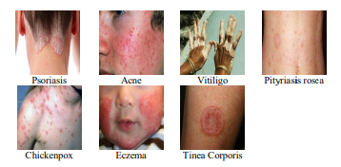

Figure 5: sample images of dataset

Saliency maps are used to visualize how the model predict each class with a given input [5]. The generated heatmap provide a way to visualize the location of the pixels where the model puts most of its attention for diagnosis [6]. As can be seen, the model most set it’s focus where the lesion is located.

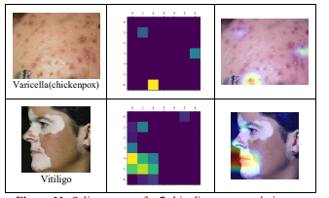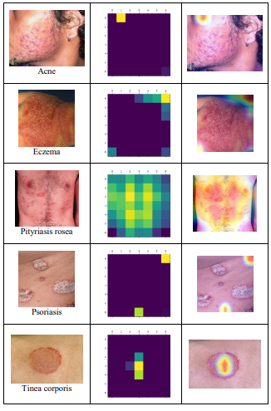





Figure 6: Saliency maps for 7 skin disease example images

Esteva et al. [7] achieved good recognition rate between keratinocytic carcinoma and benign seborrheic keratosis, malignant melanoma and benign nevus using InceptionV3 CNN architecture on Dermofit and ISIC datasets reaching the level of human dermatologists. This landmark research has attracted wide attention, especially in the field of AI in skin diseases.

Sun et al. [8] introduced datasets SD-198 and SD-128 based on DermQuest (now merged to Derm101). Several kinds of manual features extraction methods and Deep Learning methods are compared on these two datasets. SD-198 contains 198 different diseases, a total of 6,584 images. SD-128 is a subset of SD198, ensuring that each class has more than 20 images. This benchmark dataset encourages many studies about visual skin disease classification.

Liao et al. [9] collected their dataset from 6 public dermatology atlas websites: AtlasDerm, Danderm, Derma, DermIS, Dermnet and DermQuest. They use CNNs for disease-targeted and lesion-targeted classifications and draw a conclusion that the classification method with lesion tags can get better performance.

In [10] they establish a large-scale, Asian-dominated clinical image dataset of skin diseases called XiangyaDerm, and carries out researches on it.

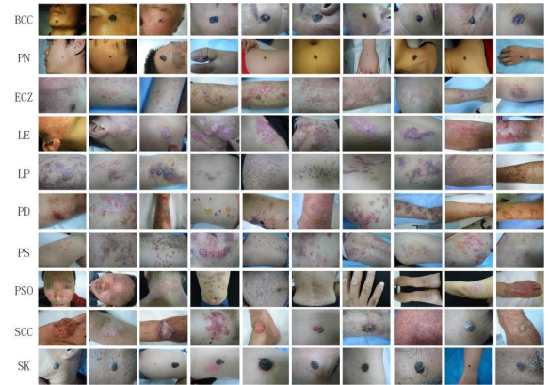

Figure 7: Some sample images in XiangyaDerm. Each line from top to bottom are clinical images of basal cell carcinoma (BCC), pigmented nevus (PN), eczema (ECZ), lupus erythematosus (LE), lichen planus (LP), pemphigoid (PD), pemphigus (PS), psoriasis (PSO), squamous cell carcinoma (SCC), and seborrheic keratosis (SK)

In order to evaluate the performances of different CNNs on this dataset and prove the usefulness of it, they select 4 mainstream CNN architectures, including InceptionV3, InceptionResNetV2, DenseNet121 and Xception to classify 80 common skin diseases

The image input size for InceptionV3, InceptionResNetV2 and Xception are both 299×299×3 and for Densenet121 is 224×224×3. they kept the rest of the experimental conditions consistent, for example, setting the same pretrained weights on ImageNet dataset, max training epochs 5000, basic learning rates 0.001, batch size 25, optimizer Adam, and the loss function categorical cross entropy. By organizing 4-fold cross validation experiments, they summarize the average values of the experimental results.

# 2.1 Similar programs

Common Advantages:

1. The Easy-to-use apps helps offers suggested conditions to the disorder’s image uploaded
2. Gives automatic 24/7 service.
3. Provides dermatologist reviewed information.
4. Ask questions like age, sex, location, race and skin types.
5. Scheduled Notifications:these apps will allow you to set notifications so you don’t forget your next check

# 2.1.1 Skin Check: Dermatology App

* This online telemedicine app allows you to access your virtual doctor to help you find out about your skin diseases, skin problems, or suspicious moles

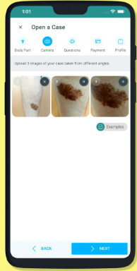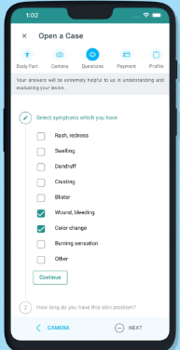

Advantages:

* **Mobile Dermoscopy:** These images are more information-rich than normal camera images. These more detailed images of your skin moles will lead to accurate recommendations.

Disadvantages:

* Costs 59.90NIS for a response.



# 2.1.2 Aysa Application

* **the easy-to-use app to get personalized answers to your skin condition questions for Free**. Aysa helps you screen your skin symptoms and prepare for your practitioner visit.

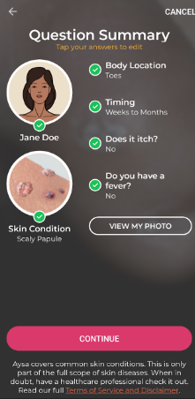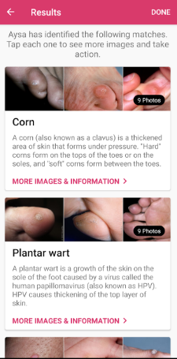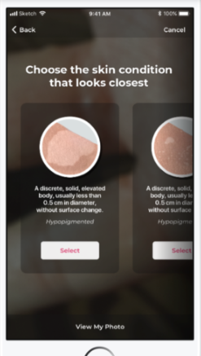

Advantages:

* Free to use, no need to pay for dermatologist reviews or memberships
* Possible to send picture directly to a professional doctor for treatment advice.



# AI Dermatologist skin scanner

* **an innovative app helping you monitor your skin health and detect any unusual or alerting skin conditions**. We all want to have healthy and clear skin, and in order to achieve this result, it is necessary to make an effort and try different skin care methods.

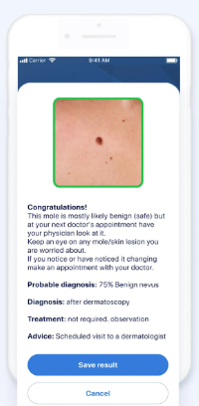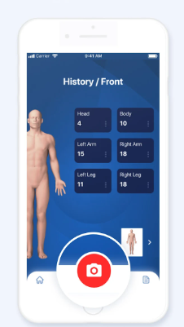 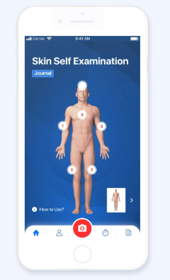

Disadvantages:

* Only 1 weekly scan for free
* No direct contact with a dermatologist from the App

# The Networks

# Convolutional neural network

CNN is a multi-layered feed forward neural network consists of many hidden layers on top of each other to learn hierarchical features and solve complicated classification for large database.

It is one of the most used deep learning algorithms, which applied to analyze visual imagery: image classification, video recognition, medical image analysis, etc.

CNN receives a colored input image and treats it as a three-dimensional matrix. The first and second dimensions are the width and height of the image respectively, whereas the third dimension refers to RGB (red, green, blue) channels with size 3 (for greyscale image the third-dimension size is 1).

The input passes through the hidden layers that consists of a series of convolution layers, pooling and fully connected layers.

There are also ReLU and stride layers.

Softmax function is applied to classify an object with probabilistic values in range of [0,1].

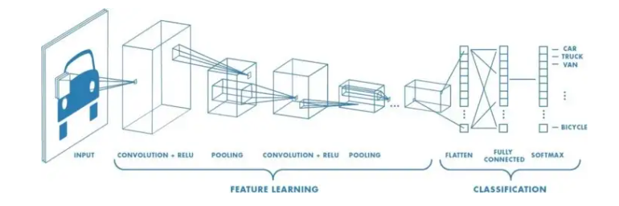

Figure 9: Convolutional Neural Networks (CNN) process from left to right of an input image is scanned for learning it’s features.

**2.2.2 Convolution Layer:**

Convolution layer is the most important layer due to the fact it consists of a set of filters, in order to learn the features of the input.

A filter, also called convolutional kernel, is a matrix (Width × Height) of learnable weights which is learned using the backpropagation algorithm and is trained to detect features.

The convolution layer is implemented by convolution operation which extracts features range from simple features in the lower convolutional layers like blurring, sharpening, edge detection, noise reduction to more abstract features in the higher convolutional layers that can help the machine to learn specific characteristics of an image without damaging the resolution.

To perform the convolution, the filter slides over input matrix and operates a multiplication between each element in the input matrix by the element of the kernel respectively.

A very important note is that the depth of this filter has to be the same as the depth of the input (Fig. 10).

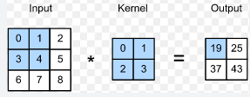

Figure 10: Convolution between Image and filter.

All those multiplications are summed into a 2-dimensional activation map that gives the responses of that filter at every spatial position (shown in Fig. 11).

The output will be a volume of stacked activation maps with a depth dimension that was extracted from the convolved features.

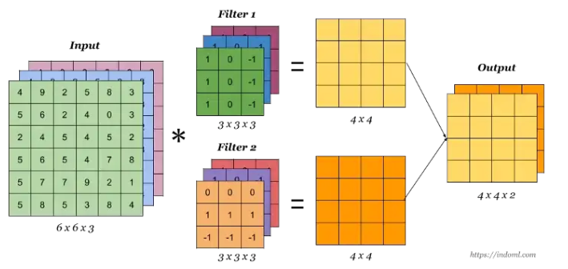



Figure 11: Showing the filter depth is equals to depth of the input image

**2.2.3 Pooling Layer:**

Pooling Layer is a middle-layer which reduces the dimension of the previous layer’s feature maps.

In order to decrease the complexity and computational power required to process the information, there are few techniques for performing the action such as average pooling and the most common is max pooling. Max pooling selects the maximum value from each sub-region. [12]

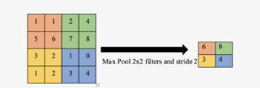



-

Figure 12: Max pooling is demonstrated. The max pooling with 2x2 filter and stride 2 lead to down sampling of each 2x2 blocks is mapped to 1 block

**2.2.4 Soft Attention**

Soft attention can be used to help the model focus on certain areas of an image that are more relevant to the task of disease detection. For example, the soft attention mechanism might help the model focus more on texture or color patterns in an image that are characteristic of a particular skin disease, while ignoring other features that are less relevant. This can help the model make more accurate predictions, especially when dealing with images that have a lot of clutter or other distracting features. This unit multiplies the corresponding feature maps with low weights. Thus, the low attention areas have weights closer to 0. As the information gets more focused, the model performs better. the architecture of a model with soft attention has an encoder that processes the input data and extracts features from it, and a decoder that uses the attention weights to weight the importance of different features in making a prediction.

**2.2.5 Categorical cross entropy loss:**

Categorical cross entropy loss is a good choice for optimizing networks for skin disease prediction because it is effective at measuring the distance between the predicted and true class labels and can handle a large number of classes efficiently and commonly used loss function for training classification models. The loss is minimized during training to optimize the network for the classification task. It’s well-suited for classification tasks with a large number of classes, such as skin disease prediction, because it is able to handle a large number of class labels efficiently.

We want to classify several types of skin disorders from the databases we gathered. We use the loss function based on categorical cross entropy loss ( $L_{cce})$ which be used to optimize our network.

$$L_{cce}=-\sum_{i=1}^{C}{t_{i}\log\left({f(s)}_{i}\right)}$$

Where

$${f(s)}_{i}=\frac{e^{s_{i}}}{\sum_{j=1}^{C}{e^{s_{j}}}}$$

C $∈[0..255]$ presents the types of disorders, $t_{i}$ presents the ground truth and $s_{i}$ is the CNN score for each class i in C. ${f(s)}_{i}$ presents the softmax function applied to the scores.

**2.3 Previous fellow’s architectures**

**The most previous fellows –** **Lipaz and Mor:**

Lipaz and Mor used “Resnet-50” and “Densenet-121” networks, that have been pre-trained using the ImageNet database,

**2.3.1 ResNet:**

ResNet is a type of convolutional neural network (CNN) that was developed to address the problem of training very deep neural networks. It does this using "skip connections," which allow the network to skip over some layers, effectively making the network deeper without increasing the risk of overfitting, using a ReLU nonlinear activation function. ResNet uses the forward and backward propagation methods. Among the advantages easier optimization, handles the gradient vanishing issue, uses the forward and backward propagation methods.

**2.3.2 ResNet50:**

ResNet-50 specifically refers to a version of the ResNet network that has 50 layers. It is a relatively deep network and has a large number of parameters, making it more powerful than smaller ResNet models. It is often used as a base model for image classification tasks, and has achieved state-of-the-art results on several benchmarks.

**2.3.3 DenseNet:**

DenseNet is a type of convolutional neural network (CNN) that is designed to be more efficient and easier to train than other CNNs. It does this by using "dense" connections between layers, where each layer receives input from all of the previous layers, rather than just a few. This allows the network to learn more robust features and can make training faster and more efficient. Each layer in DenseNet consists of a feature map. The feature map of each layer serves as an input to the next layer. Among the advantages of DenseNet is that it requires fewer parameters. In DenseNet, the number of direct connections is $\frac{L\left(L+1\right)}{2}$. , it decreases the chance of the model to overfitting due to the small size training dataset by applying regularization.

**2.3.4 DenseNet121:**

DenseNet-121 specifically refers to a version of the DenseNet network that has 121 layers. It has a relatively small number of parameters, making it faster to train and easier to use than larger DenseNet models. It is often used as a base model for image classification tasks, and has achieved state-of-the-art results on several benchmarks.

**The first previous fellows – Or and Niv:**

Or and Niv used the same “DenseNet121” their previous used, with Inception “ResNet v2 – IRv2”.

**2.3.5 Inception ResNet v2 – IRv2:**

ResNet v2 is a version of the ResNet convolutional neural network (CNN) that was developed to address some of the issues with the original ResNet architecture that we will explain shortly after, it’s often used as a base model for image classification tasks, and has achieved state-of-the-art results on several benchmarks. It is also used in other tasks such as object detection and semantic segmentation, the skip connections it uses has an identity mapping, which means that the input is passed through a linear function (a 1x1 convolution) before being added to the output. This allows the network to learn more complex functions and can improve its performance on certain tasks.

**2.3.6 Networks we will use in our project:**

The networks we use are ResNet v2 and DenseNet-121 are both highly effective convolutional neural networks (CNNs) that have achieved state-of-the-art results on a variety of image classification tasks. They are therefore good candidates for use in skin disease detection.

***Some specific reasons for using ResNet v2 and DenseNet-121 for skin disease detection include:***

* **Good performance:** they are known to be effective at classifying images, and may be able to achieve good performance on skin disease detection tasks.
* **Robust features**: they are able to learn robust features from images, which can be useful for detecting subtle differences between different skin diseases.
* **Ease of training:** they are relatively easy to train, which can make it faster and easier to develop a skin disease detection system using these models.
* **Widely used:** they are both widely used in the field of computer vision, and there is a wealth of resources and knowledge available for using these models.

Overall, ResNet v2 and DenseNet-121 are good choices for skin disease detection because of their good performance, robust features, ease of training, and wide adoption in the field.

**3. Expected Achievements**

What we achieved is that the system we built will provide instant indication and prediction of the uploaded skin disease image of the user that might be in different resolutions, image qualities, lightning conditions and skin colors, these images are cropped and transferred through some color filters and edge detection algorithms to enhance their features in order to properly predict the disease. Our system will predict and display the closest similarity and most accurate predictions possible for his skin disorder. The user can see the closest similar displayed disorder and can see the description of the chosen disorder, and after the user uploads the disorder image we can add it to our dataset for better future predictions capabilities, this prediction will save him long medical procedure bureaucracy.

The success of our project will depend on the ability of the model to accurately identify different skin diseases, while taking in consideration the special cases of each disease and identifying one’s that the disease is absent, while taking in consideration the user’s feedback and satisfaction.

**4. Research process**

# 4.1 Process

We started by searching for a new database of diseases that includes all types of skin diseases and disorders possible, researched some of the best networks that will work for our huge database of diseases of different classes, including searching and reading several papers that talk about skin disorders, AI, deep learning, also for applications and existing programs that are very similar to ours to detect skin diseases, took into consideration each advantage and disadvantage they had. And our goal is that the system of mass wisdom that we built will predict all types of skin disorders and diseases instantly that is easy to use. The motivation for approaching the process and various stages of the work was to build it little by little while consulting with our supervisor and fixing all the issues we had especially in understanding difficult medical papers that talk about different skin diseases and to know the background of each one to understand how it applies on our project that it can predict similar ones to it and give the informative description about it, and now we took all that knowledge we had and started to built the model for training in python using at first Google Collab, while saving the weights after 50 epochs everyday, until we have reached 90%+ accuracy, we saw the model is trained very good and able to predict and classify diseases logically so we continued to test the model in order to see how good it is predicting, and then we had to learn how to develop a web server in Angular and to send http requests from the frontend to our backend the python server, in order to be able to show images and predictions on the frontend for the User to use, it took lots of weeks and months to build it so it can look functional and predict with high accuracy each disease and to show multiple close diseases for the uploaded image for the user after him filling in his background information and descriptions of the disease and the area of it so the system can predict and learn further, after predicting the system provides a long list of the top predictions with accuracy and description of each disease and giving him the ability to choose which one of the diseases is the most similar to his, so we can learn from his feedback and also to save him lots of bureaucracy of going to dermatologic expert and providing instant indication of it.

**4.2 Product**

Our product in comparison with our previous fellows is that in our model we are willing to increase the prediction and performance to detect several more skin disorders than just skin cancer.

# The model based on images created by the users, with this data we will expand out training data to get better performance

# We expanded the dataset they had in order to predict more and more skin disorders now we have 256 classes.

# Using a Soft Attention unit to the IRv2 network increasing the prediction rates and focusing on relevant features of the image.

# Our model will have additional description and background that the user can write to describe his disease

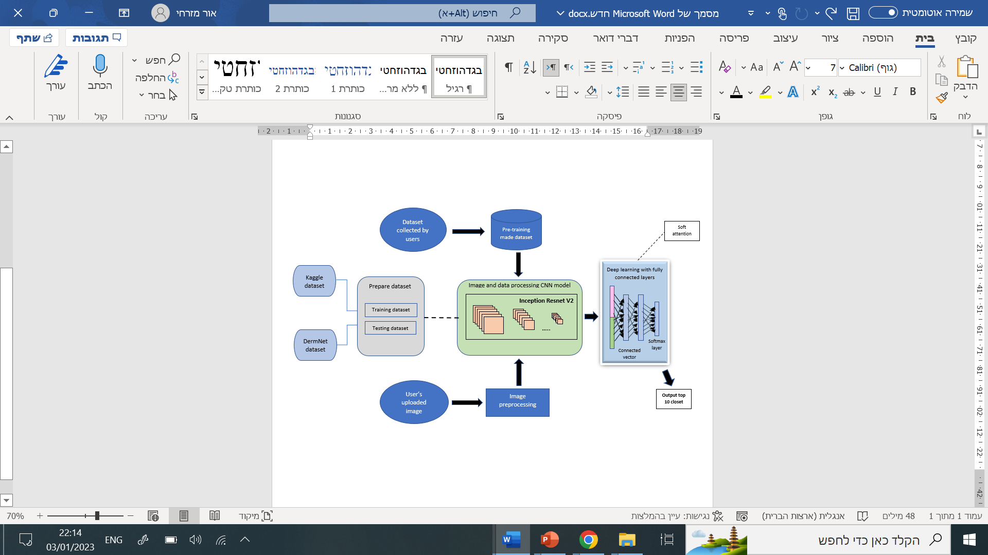

**4.2.1 Use Case Diagram:**

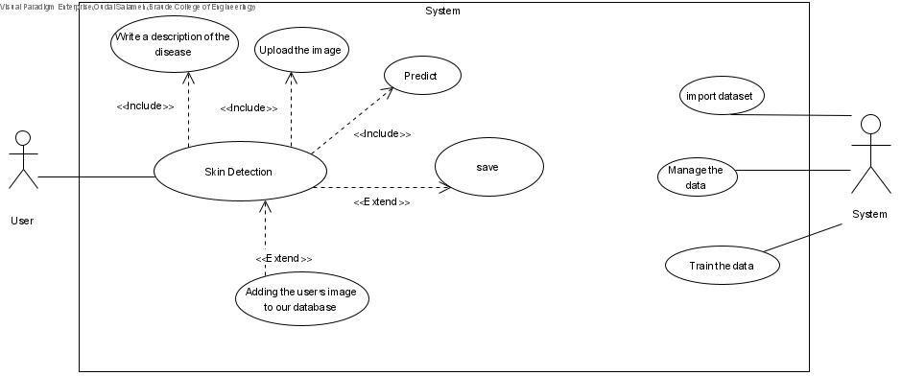

Saving result as pdf

**4.2.2 Class Diagram:**

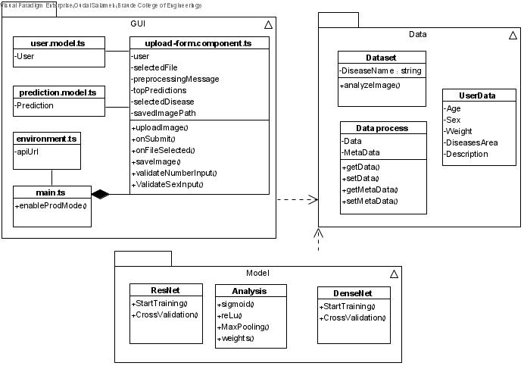

**4.2.3 Deployment Diagram:**

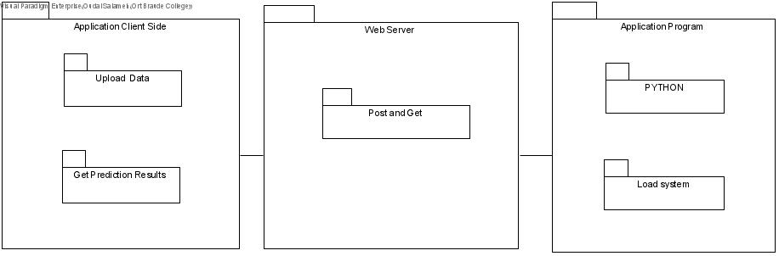

**4.2.4 Simple user flowchart:**

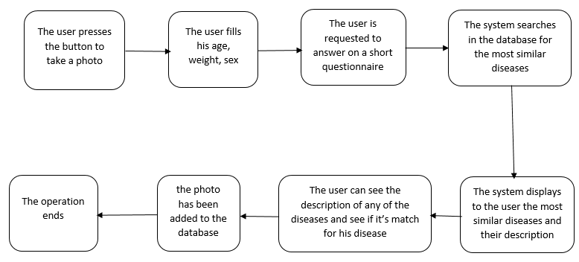

fill in disease area and description

**4.2.5 Datasets**

Our datasets that have been used at our model are gathered from DermNet while searching for all the skin disorders possible for humans and Kaggle’s skin disorder dataset. DermNet’s dataset is a large collection of multisource dermatoscopic images of different sizes, consists of 20,113 different disorders, most of the images are size of 294 X 222 and multiple disorders captured by camera. The Kaggle’s skin disorders dataset consists of several disorders images of different sizes 220 X 112 and consists of 20 different diseases. The data in both datasets is then cleaned to remove class imbalances using our filters, so after all the searches we gathered 256 classes of skin disorders each for the training and testing.

**4.2.6 GUI:**

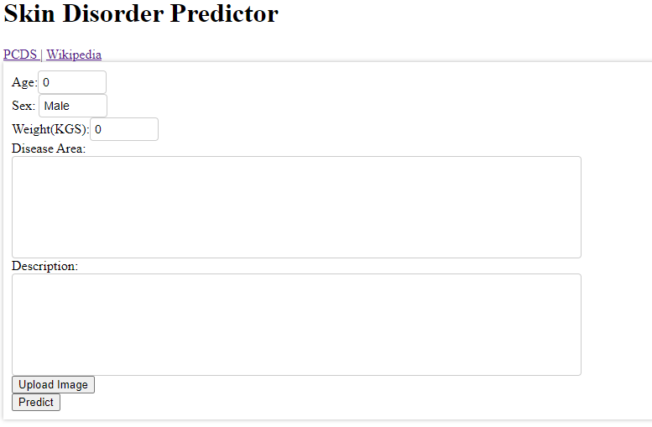

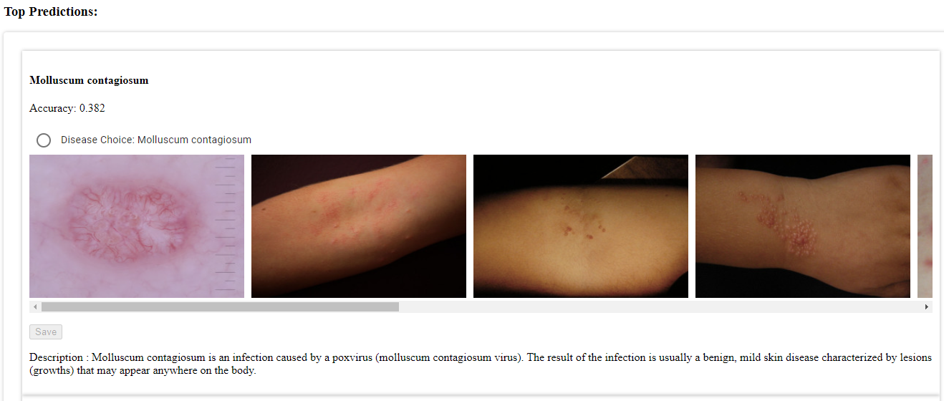

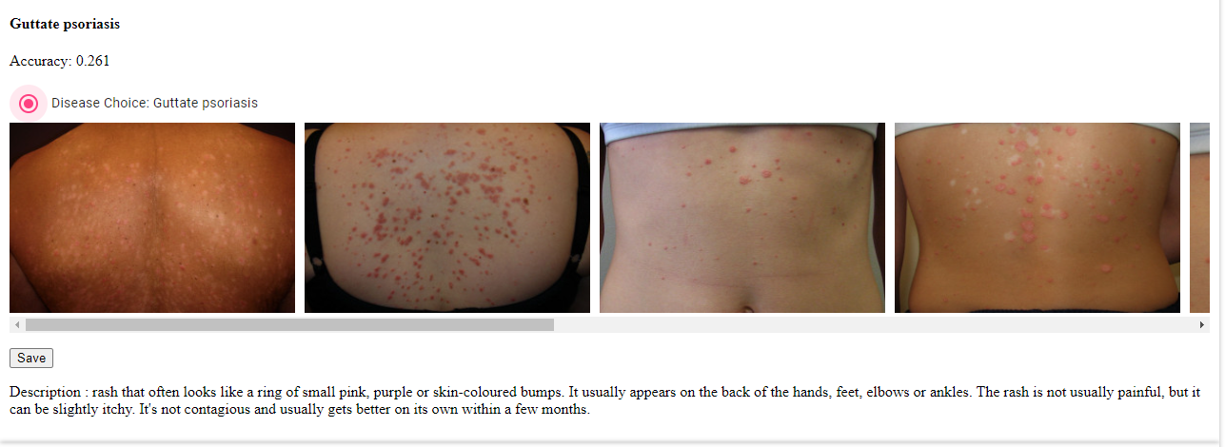

**After saving:**

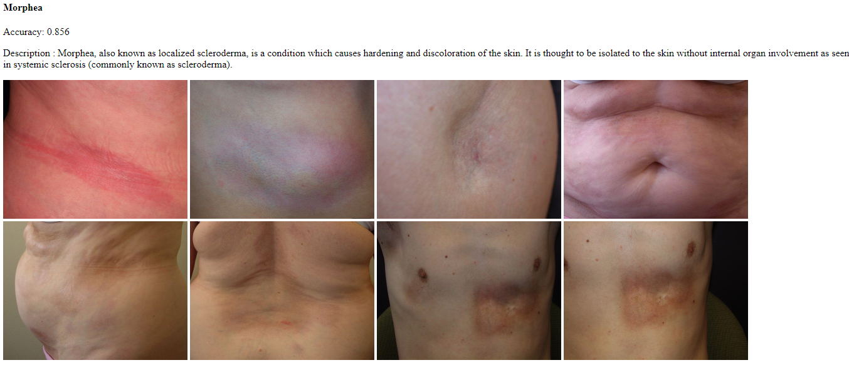

**Possibility to save as PDF:**

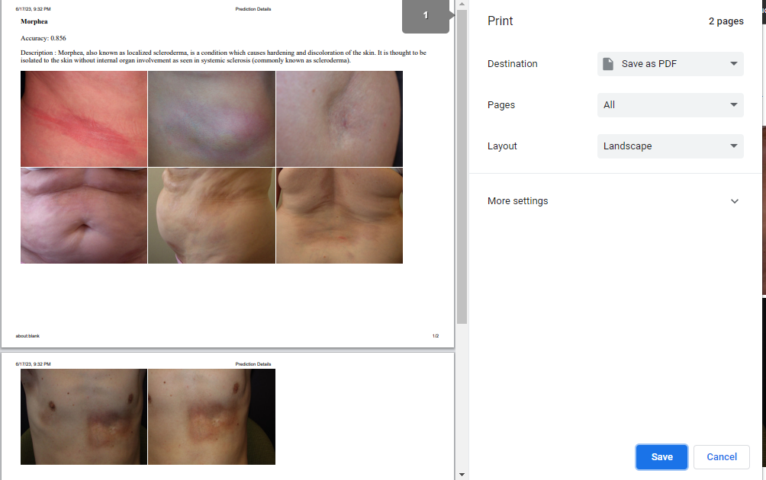

**5. Verification Plan**

|  |  |  |
| --- | --- | --- |
| **The Test subject** |  | **Expected result** |
| Upload/take a photo | V | The system will process the photo and grant an access to see the prediction |
| Upload/take a blurry photo | V | The system will try to process the photo and grant an access to see the prediction that is not accurate |
| Try predicting without taking/uploading a photo | X | The system will not allow to click on predict button |
| Trying to predict without entering age | V | The system will auto input 0 |
| Trying to predict without entering weight | V | The system will auto input 0 |
| Trying to predict without entering sex | V | The system will auto input ‘Male’ |
| Trying to predict without entering disease area | V | The system will keep it empty |
| Trying to predict without entering description | V | The system will keep it empty |
| Show the predicted diseases | V | The system will display a list of the most accurate diseases and their description. |
| Save the prediction as a HTML file | V | The system will allow to export the prediction as a HTML file thereby allowing the user to print( save as PDF) |

**6. Evaluations**

|  |  |
| --- | --- |
| Disease | Accuracy |
| Acne | 0.99999 |
| Actinic keratosis | 0.51914 |
| Basal cell carcinoma | 0.9999998 |
| Nail fungus | 0.99999997 |
| Light diseases and disorders of pigmentation | 0.8259 |
| Abscess | 0.00133 |
| Acanthosis nigricans | 0.01246 |
| Acral lentiginous melanoma | 0.02523 |
| Acropiustlosis | 0.01428 |
| Actinic granuloma | 0.00047 |

Table 1: Showing diseases and the accuracy of predicting them.

|  |  |  |  |
| --- | --- | --- | --- |
| Disease | Accuracy | #Training images | #Testing Images |
| Acne | 0.99999 | 82 | 25 |
| Actinic keratosis | 0.51914 | 114 | 16 |
| Basal cell carcinoma | 0.9999998 | 376 | 116 |
| Nail fungus | 0.99999997 | 140 | 32 |
| Light diseases and disorders of pigmentation | 0.8259 | 300 | 30 |
| Abscess | 0.00133 | 7 | 3 |
| Acanthosis nigricans | 0.01246 | 5 | 2 |
| Acral lentiginous melanoma | 0.02523 | 22 | 9 |
| Acropiustlosis | 0.01428 | 5 | 2 |
| Actinic granuloma | 0.00047 | 5 | 2 |

Table 2: Showing accuracy of predicted diseases and their number of images that the system has been trained and tested on.

Accuracy

Training images

Graph 1: Showing the relation between accuracy and number of training images

**7. Conclusion:**

In this project, we developed a reliable, fast, and accurate platform for the detection of multiple skin disorders. We proposed a system based on convolutional neural networks, specifically the Inception ResNet V2 and Densenet-121 architectures. The system utilizes a vast database of skin images uploaded by users, along with personal data (age, weight..) to improve the ability to diagnose and detect skin diseases.

Through our research, we reviewed related works and identified various approaches in the field of skin disorder detection, including the use of AI algorithms and deep learning architectures. We found that these methods have shown promising results in classifying and diagnosing different skin diseases.

Our proposed solution incorporates the datasets from DermNet and PCDS. This approach allows the analysis and detection of skin disorders even in low-quality images taken on mobile devices, and by having more data possible for training, the more accurate predictions will be.

The system includes a user-friendly interface with features such as suggested conditions based on uploaded images. Users are presented with the most accurate predictions for diseases along with accompanying images, relevant information and description, all of which can be saved for future reference and improvements.

To evaluate the performance of our system, we established a verification plan and presented accuracy tables comparing our results with existing research. The system achieved high accuracy rates in classifying different skin diseases, demonstrating its effectiveness in diagnosis of predicting skin disorders when the training stage had enough images for the network to learn from.

In conclusion, our project presents a robust solution for the detection of multiple skin disorders. By harnessing the power of convolutional neural networks and utilizing a comprehensive database, we have developed a platform that can aid in the early indication and diagnosis of skin diseases. This technology has the potential to streamline the medical procedure process and bureaucracy and provide accessible healthcare to a wider population.

**8. Maintenance Guide:**

In order to maintain the project keep the following instructions of libraries installs up to date simultaneously:

1) install angular 16.0.3

1.1) Install Spyder (python 3.8) in Anaconda

1.2) Install npm 9.5.1

2) Install node.js

3) In cmd install angular cli

4) Install all the neseccary node_modules and libraries needed for the python code

5) Option 1:

Download the full project from the google drive link:

<https://drive.google.com/drive/folders/1_T1ghKs5HY9o6fwpIeM1TA7ISPyzrkx7?usp=sharing>

Extract it

Option 2:

Github download the project: SkinDisorderAngular from link : <https://github.com/Oudai46/Detection-of-multiple-skin-disorders>

Downloads: from the shared google drive links:

Data: <https://drive.google.com/drive/folders/1_eWjFvoxhGrUwZYNR87bhxpk5bDnojqA?usp=drive_link>

Weights: <https://drive.google.com/file/d/1Kd44MVYLm4bhN19ApOulZUJZl8o2zwJ6/view?usp=drive_link>

Download the model_weights_0_epoch1.h5 file that has all the trained weights for predicting diseases,and put in the server folder inside the SkinDisorderAngular/SkinDisorder/src/app/server

Download the Data folder also and save it in 2 places, 1st place inside the SkinDisorderAngular/SkinDisorder/src/app/server in order for the python file to read it and use it, the 2nd place is inside the SkinDisorderAngular/SkinDisorder/src/app/assets for the correct relative links to work for prediction.

6)Run the python backend Server in Spyder- anaconda , and then run the angular frontend by typing ' ng serve' in terminal inside the SkinDisorderAngular/SkinDisorder/src/

- If you have done all the steps correctly you should see in the python server '200' response meaning that they are properly connected

7)Fill in the necessary details and upload an image of a disease and click predict.

**9. References:**

1. <https://www.ncbi.nlm.nih.gov/pmc/articles/PMC9060152/>

2. H. Alquran, I. A. Qasmieh, A. M. Alqudah, S. Alhammouri, E. Alawneh, A. Abughazaleh, and F. Hasayen. The melanoma skin cancer detection and classification using support vector machine, in 2017 IEEE Jordan Conference on Applied Electrical Engineering and Computing Technologies (AEECT), pp. 1-5, 2017.

3. X. Zhang, S. Wang, J. Liu, and C. Tao. Computer-aided diagnosis of four common cutaneous diseases using deep learning algorithm. in 2017 IEEE International Conference on Bioinformatics and Biomedicine (BIBM), pp. 1304-1306, 2017.

4. https://arxiv.org/ftp/arxiv/papers/1911/1911.07929.pdf

5. D. Goldfarb. Understanding Deep Neural Networks Using Topological Data Analysis. arXiv preprint arXiv:1811.00852, 2018.

6. N. Li, H. Bi, Z. Zhang, X. Kong, and D. Lu. Performance Comparison of Saliency Detection, Advances in Multimedia, pp. 1-13, 2018. https://doi.org/10.1155/2018/9497083

7. Esteva A, Kuprel B, Novoa R A, et al. Dermatologist-level classification of skin cancer with deep neural networks[J]. Nature, 2017, 542(7639): 115

8. Sun X, Yang J, Sun M, et al. A benchmark for automatic visual classification of clinical skin disease images[C]//European Conference on Computer Vision. Springer, Cham, 2016: 206-222.

9. Liao H, Li Y, Luo J. Skin disease classification versus skin lesion characterization: Achieving robust diagnosis using multi-label deep neural networks[C]//Pattern Recognition (ICPR), 2016 23rd International Conference on. IEEE, 2016: 355-360.

10. <https://airl.csu.edu.cn/PDFs/LABELS2019_XiangyaDerm.pdf>